**Batch: A4 Roll No.: 16010122082**

**Experiment / assignment / tutorial No. 03**

**Grade: AA / AB / BB / BC / CC / CD /DD**

**Signature of the Staff In-charge with date**

|  |
| --- |
| **TITLE :Multi-dimensional Arrays (Jagged Array)** |

**AIM:** Write a program which stores information about n players in a two dimensional array. The array should contain the number of rows equal to the number of players. Each row will have a number of columns equal to the number of matches played by that player which may vary from player to player. The program should display player number (index +1), runs scored in all matches and its batting average as output. (It is expected to assign columns to each row dynamically after getting value from the user.

**_____________________________________________________________________**

**Expected OUTCOME of Experiment:**

**CO2:** Explore arrays, vectors, classes and objects in C++ and Java.

**______________________________________________________________________**

**Books/ Journals/ Websites referred:**

1. E. Balagurusamy , “Programming with Java” McGraw-Hill.
2. Sachin Malhotra, Saurabh Choudhary, “Programming in Java”, Oxford Publications.

**_____________________________________________________________________**

**Pre Lab/ Prior Concepts:**

Arrays

**Multi-Dimensional Array**:

10 12 43 11 22

20 45 56 1 33

30 67 32 14 44

40 12 87 14 55

50 86 66 13 66

60 53 44 12 11

A multi-dimensional array is one that can hold all the values above. You set them up like this:

**int[ ][ ] numbers = new int[**6**][**5**];**

The first set of square brackets is for the rows and the second set of square brackets is for the columns. In the above line of code, we're telling Java to set up an array with 6 rows and 5 columns.

aryNumbers[0][0] = 10;  
aryNumbers[0][1] = 12;  
aryNumbers[0][2] = 43;  
aryNumbers[0][3] = 11;  
aryNumbers[0][4] = 22;

So the first row is row 0. The columns then go from 0 to 4, which is 5 items.

**Class Diagram:**

**Algorithm:**

1. Start

2. Prompt the user for n, the number of players.

3. Create a 2D array with number of rows as n

4. Run a for loop from 0 to n

5. Prompt the user for number of ,matches played for each player

6. Prompt the user for each score

7. Print the jagged array using nested for loop

8. Calculate the average and display it.

9. End

**Implementation details:**

import java.util.*;

public class Jagged {

    static int players[][];

    public static void main(String args[])

    {

        Scanner s = new Scanner(System.in);

        System.out.println("Enter the number of players");

        int n = s.nextInt();

        int players[][] = new int[n][];

        int m;

        for(int i = 0; i < n; i++)

        {

            System.out.println("Enter the number of matches of player " + (i + 1));

            m = s.nextInt();

            players[i] = new int[m];

        }

        for(int i = 0; i < n; i++)

        {

            for(int j = 0; j < players[i].length; j++)

            {

                System.out.println("Enter score number " + (j + 1) + " of player " + (i + 1));

                players[i][j] = s.nextInt();

            }

        }

        System.out.println("Displaying the jagged array");

        for(int i = 0; i < n; i++)

        {

            for(int j = 0; j < players[i].length; j++)

            {

                System.out.print(players[i][j] + " ");

            }

            System.out.println();

        }

        System.out.println("\nThe average of the players scores are:\n");

        for(int i = 0; i < n; i++)

        {

            int sum = 0;

            for(int j = 0; j < players[i].length; j++)

            {

                sum += players[i][j];

            }

            System.out.println("The average of player " + (i + 1) + " is " + (float)sum/players[i].length);

        }

    }

}

**Output:**

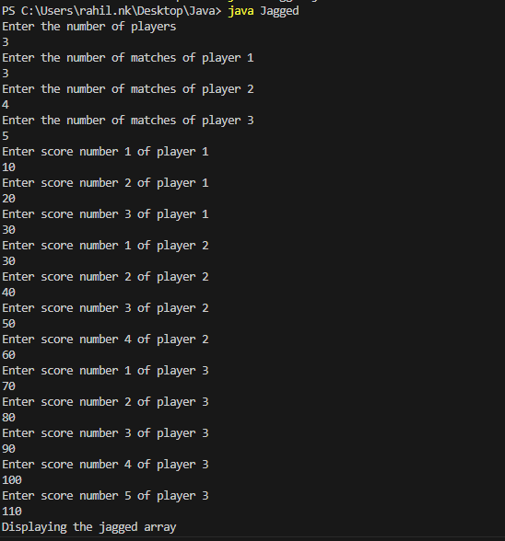

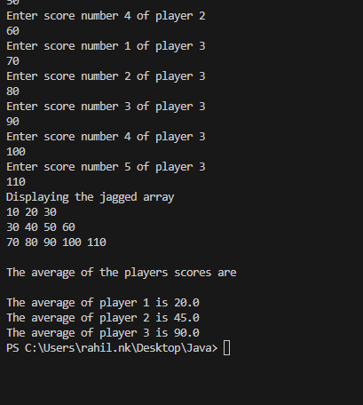

**Conclusion:**

We have learned about two d and jagged arrays in java.

**Date: _____________ Signature of faculty in-charge**

**Post Lab Descriptive Questions**

**Q.1 Create a jagged array of integers. This array should consist of two 2-D arrays. First 2-D array should contain 3 rows having length of 4,3,and 2 respectively. Second 2-D array should contain 2 rows with length 3 and 4 respectively.**

public class jaggedpostlab {

    public static void main(String[] args)

    {

        int j1[][] = new int[3][];

        j1[0] = new int[4];

        j1[1] = new int[3];

        j1[2] = new int[2];

        int j2[][] = new int[2 ][];

        j2[0] = new int[3];

        j2[1] = new int[4];

    }

}

**Q.2 Consider the following code**

int number[] = new int[5];

After execution of this statement, which of the following are true?

(A) number[0] is undefined

(B) number[5] is undefined

(C) number[4] is null

(D) number[2] is 0

(E) number.length() is 5

(i) (C) & (E)

(ii) (A) & (E)

(iii) (E)

(iv) (B), (D) & (E)

Option 4

**Ans:**

**Q.3 Write a program to create an array where ith row has i columns.**

import java.util.*;

public class Jagged {

    static int players[][];

    public static void main(String args[])

    {

        Scanner s = new Scanner(System.in);

        System.out.println("Enter the number of rows");

        int n = s.nextInt();

        int jagged[][] = new int[n][];

        int m;

        for(int i = 0; i < n; i++)

        {

            jagged[i] = new int[i + 1];

        }

    }

}